Sofia Lehmuskallio  Head of Practice Support, Stockholm  +46 8 553 190 00  +46 7 382 384 20  sofia.lehmuskallio@roschier.com | 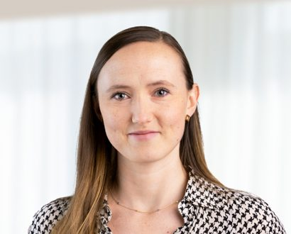

Sofia Lehmuskallio is an experienced talent supply chain professional with a demonstrated history of working in the information technology and services industry on an international level. She is skilled in people leadership, collaboration, complex work environments, HR planning, talent and supply/demand management. Sofia has a passion for both people and business development.

Career
Roschier (2021-)
Accenture, Supply Demand Balancing Lead, Talent Supply Chain Lead (2017-2021)
Accenture, Resource Pool Specialist, Client Supply Demand Specialist Lead From (2015-2019)

Education
University of Helsinki, Master of Social Sciences (sociology, communication) (2010)

Languages
English, Finnish, Swedish

