Mirva Hauskaviita  Brand Protection Lead, Helsinki  Brand Protection, Intellectual Property  +358 20 506 6681  +358 40 536 4292  mirva.hauskaviita@roschier.com | 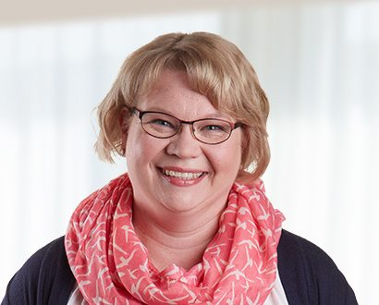

Mirva Hauskaviita is a Helsinki-based Brand Protection Lead. She is responsible for trademark and design right portfolio maintenance, which includes trademark and design right renewals, assignment and other formality recordals with respective Intellectual Property Offices in Finland and abroad. Mirva is an authorized trademark attorney in Finland.

Career
Roschier (2012-)
Benjon Oy, IP Specialist, Assistant Coordination (1999-2012)

Memberships
Member of the Finnish Industrial Property Association (STY)

Languages
English, Finnish

