Mira Ahonen  Senior Associate, Helsinki  Private M&A, Private Equity  +358 20 506 6820  +358 44 268 1826  mira.ahonen@roschier.com | 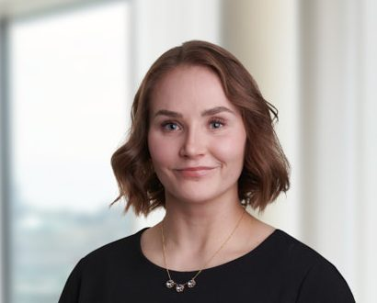

Mira Ahonen is a Helsinki-based Senior Associate working with Roschier’s Private M&A practice. She has extensive experience in advising both Finnish and international clients on complex multi-jurisdictional transactions, representing both private equity sponsors and corporate clients. In addition to private M&A transactions, she has been advising clients on capital markets transactions, including public tender offers and dual-track transactions. Prior to joining Roschier in 2022, she gained experience working for a Big Four company.

Work highlights
Mira Ahonen’s experience includes advising:

- Tietoevry’s sale of its Tech Services business area to funds advised by Agilitas Private Equity LLP;
- HD Korea Shipbuilding & Offshore Engineering Co., Ltd. in acquiring a majority stake in Convion Oy;
- Advanced Micro Devices, Inc. in acquisition of Silo AI Oy
- Tietoevry in the strategic review, planned demerger and listing or sale of its Banking business;
- Brown-Forman in the sale of Brown-Forman Finland Oy, owner of the Finlandia vodka brand, to Coca-Cola HBC;
- Inflexion in its acquisition of Nomentia from PSG, Verdane and certain management sellers; and
- Bain Capital-led consortium in the cash tender offer for all shares in Caverion.

Career
Roschier, (2022-)
EY, Legal Counsel and Associate Legal Counsel (2019-2022)

Memberships
Member of the Finnish Bar Association

Education
University of Copenhagen, LL.M. (2019)
University of Helsinki, Recognition of foreign LL.M diploma as the Finnish Master of Laws degree (2022)

Languages
English, Finnish, Swedish

