Miisa Happonen  Senior Associate, Helsinki  Contentious Corporate, Insolvency & Corporate Crime, Dispute Resolution  +358 20 506 6573  +358 400 661 174  miisa.happonen@roschier.com | 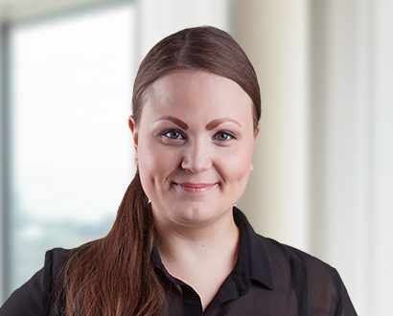

Miisa Happonen is a Helsinki-based Senior Associate working with Roschier’s Contentious Corporate, Insolvency & Corporate Crime and Dispute Resolution practices. She joined Roschier in 2018, and specializes in arbitration, litigation and corporate investigations.
Miisa has experience on both domestic and international arbitrations conducted under the ICC, SCC and FAI Rules. She has acted as counsel in disputes across several sectors, including energy, technology and telecom, as well as in post-M&A and corporate disputes. Miisa also regularly advises clients on various regulatory, anti-corruption and insolvency-related matters.
Miisa has worked as legal counsel (secondee) at the Finland Arbitration Institute (2021-2022).

Career
Roschier (2018-)
Finland Arbitration Institute, Legal Counsel (2021-2022)

Memberships
Member of the Finnish Bar Association
Member of Young Arbitration Club Finland (YACF)

Education
Finnish Arbitration Academy (2021)
University of Helsinki, LL.M. (2018)

Languages
English, Finnish

