Miia-Mari Kasi  Senior Associate, Helsinki  Finance & Restructuring  +358 20 506 6805  +358 40 756 4420  miia-mari.kasi@roschier.com | 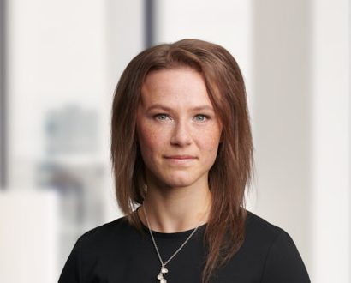

Miia-Mari Kasi is a Helsinki-based Senior Associate working with Roschier’s Finance & Restructuring practice. Miia-Mari joined Roschier in 2020.

Career
Roschier (2020-)

Memberships
Member of the Finnish Bar Association

Education
University of Helsinki, LL.M. (2020)

Languages
English, Finnish

