Laura Koivumäki  Senior Event Specialist, Helsinki  +358 20 506 6719  laura.koivumaki@roschier.com | 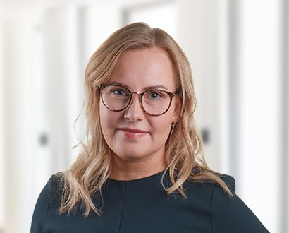

Laura Koivumäki is a member of the firm’s Communications & Branding team and is responsible for the firm’s event management. She also works with branding and firm-wide sponsorship initiatives. Laura coordinates the production of various marketing materials, both printed and digital. She joined the firm in 2012.

Career
Roschier (2012-)

Education
Haaga-Helia University of Applied Sciences, B.B.A. (2012)

Languages
English, Finnish

