Kaisu Korpua  Managing Counsel, Brand Protection , Helsinki  Brand Protection, Intellectual Property  +358 20 506 6683  +358 50 487 2996  kaisu.korpua@roschier.com | 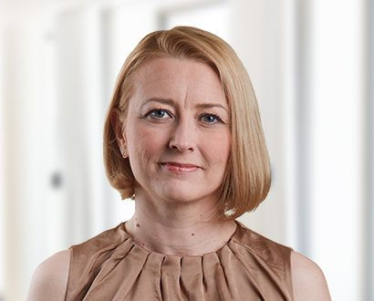

Kaisu Korpua is a Helsinki-based Managing Counsel specialized in brand protection. She has worked in the intellectual property rights field since 2000, as a trademark agent and as an in-house trademark attorney. For the last six years prior to joining Roschier’s Brands team, Kaisu had primary responsibility for a Finnish mobile phone manufacturer’s global trademark portfolio, which has given her an extensive experience in managing, drafting and implementing extensive and international protection strategies.
Kaisu is in charge of protecting the world-wide trademark portfolios of some of the biggest brand owners of Finland, and she has extensive experience in clearing, protecting and enforcing new brands for global use. She is a trusted strategic advisor for several Finnish and foreign listed companies from various industries.
Kaisu is an attorney at law and an authorized trademark attorney in Finland.

Recognitions
Kaisu is recognized as one of the leading experts in Finland within trademarks by World Trademark Review (WTR 1000), Lexology Index (formerly Who’s Who Legal), Managing IP (IP Stars), and Chambers.
This is what clients say about Kaisu:
“Kaisu Korpua is well known in the area of trade mark prosecution.”
– Chambers Global 2025, Intellectual Property
“Kaisu Korpua is a prominent figure in the field of trademark prosecution. With extensive expertise in complex cases, coupled with her responsiveness, strategic mindset and commercial insights, she is the obvious choice for clients.”
– WTR 1000 2025
“It is always nice and a pleasure to work with Kaisu Korpua. She is a real expert and an experienced IP attorney in her field.”
– Chambers Global 2024, Intellectual Property
“Kaisu Korpua is a true expert in trade mark, design and enforcement matters and is always available and responsive. I highly appreciate her support and knowledge in all kinds of IP matters.”
– The Legal 500 2024, Intellectual Property
“Kaisu Korpua is the name to note in the Finnish market for strong brand protection. She has proven herself to be a profoundly knowledgeable trademark expert, with a keen understanding of brand identity as a whole.”
– WTR 1000 2024, Finland
“She is very responsive and I greatly appreciate her expertise, especially in the most complicated trade mark matters.”
– Chambers Global 2023, Intellectual Property

Career
Roschier (2012-)
Benjon Oy, Head of IPR Team (2011-2012)
Nokia Oyj, Senior Legal counsel/Head of Trademark Team (2005-2011)
Benjon Oy, IPR Lawyer (2002-2005)
Training at the Bench, District Court of Kuusamo (2001-2002)

Memberships
Member of the Finnish Bar Association
Member of AIPPI
International Trademark Association (INTA)
Member of FICPI
Member of the Association of Finnish Patent Attorneys (SPAY)
Member of the Finnish Association for Industrial Property Rights (STY)

Education
University of Helsinki, LL.M. (2001)

Languages
English, Finnish

