Kaisa Leppänen  Senior Associate, Helsinki  Dispute Resolution  +358 20 506 6501  +358 45 670 1635  kaisa.leppanen@roschier.com | 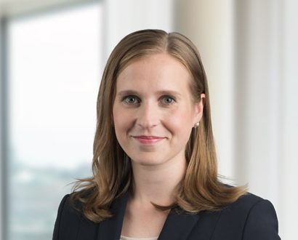

Kaisa Leppänen is a Helsinki-based Senior Associate. She works with a wide range of dispute resolution related assignments, specializing in domestic and international commercial arbitration and litigation.
Kaisa has been involved in disputes relating to e.g. energy and infrastructure, M&A transactions, international trade and transport as well as IT and telecom. She also has solid experience in various other areas such as white collar crime and cartel damages actions. Kaisa also regularly advises clients on various contractual and regulatory matters.
Prior to joining Roschier in 2016 Kaisa worked as an associate for another law firm. Kaisa has also trained at the Bench.

Career
Roschier (2016-)
Law clerk, trained at the Bench (2020)
Borenius Attorneys Ltd., Associate (2015-2016)

Memberships
Member of the Finnish Bar Association
Member of the Young Arbitration Club Finland

Education
University of Helsinki, LL.M. (2015)

Languages
English, Finnish

