Joakim Raivio  Senior Associate, Stockholm  Dispute Resolution  +46 8 553 190 52  +46 76 110 59 79  joakim.raivio@roschier.com | 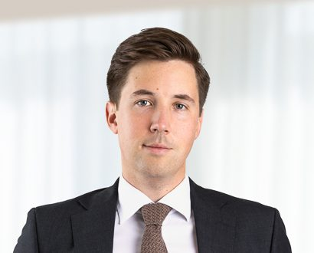

Joakim Raivio is a Stockholm-based Senior Associate working with Roschier’s Dispute Resolution practice. He has previously worked with Roschier’s Private Funds, Public M&A, Corporate Advisory and Equity Capital Markets practices, and as a Law Clerk at Solna District Court. Joakim joined Roschier in 2021.

Career
Roschier (2021-)
Solna District Court (2021-2023)

Education
Uppsala University, LL.M. (2021)

Languages
English, Swedish

