Jens Sandberg  Senior Associate, Stockholm  Intellectual Property, Dispute Resolution, General Commercial, Marketing & Consumer, Digitalization & TMT  +46 8 553 190 95  +46 72 206 99 92  jens.sandberg@roschier.com | 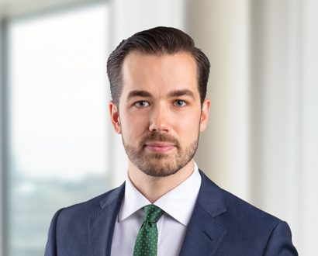

Jens Sandberg is a Stockholm-based Senior Associate. He works with Roschier’s Dispute Resolution practice but is on a temporary rotation to our Intellectual Property, General Commercial, Marketing & Consumer, Digitalization & TMT practices. In addition to his LL.M. degree from Stockholm University, he has also studied law at The University of Texas at Austin. Jens joined Roschier upon his graduation in 2017.

Career
Roschier (2017-)
The Arbitration Institute of the Stockholm Chamber of Commerce (SCC), Legal counsel (2019)

Memberships
Member of the Swedish Bar Association
Member of the Young Arbitrators Sweden (YAS) – Advisory Board (2019-2020)
Member of the Young ICCA
Member of the ICDR Young & International
Member of the ICC Young Arbitrators Forum

Education
Stockholm University, LL.M. (2017)

Languages
English, Swedish

