Iida Järnroos  Senior Associate, Helsinki  Competition, Public Procurement  +358 20 506 6790  +358 40 539 3549  iida.jarnroos@roschier.com | 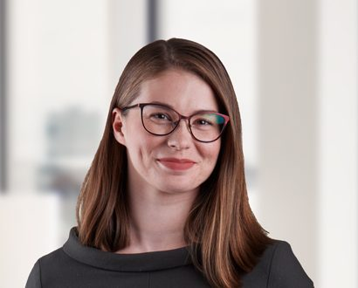

Iida Järnroos is a Helsinki-based Senior Associate. She works with Roschier’s EU & Competition practice. She has gained experience in a variety of competition law matters and has been involved with several multi-jurisdictional merger filings at the national and EU level. Her experience includes advising clients in cartel investigations, dominance matters as well as internal audits and other competition law compliance issues. In the field of public procurement, Iida has been involved in several public procurement disputes serving both corporate and public sector clients.
Iida has gained international experience in antitrust matters working as a visiting lawyer in a leading law firm in New York. In addition to her Finnish LL.M. degree, Iida has studied law at the University of Geneva, Switzerland.

Work highlights
Iida Järnroos’ experience includes advising:

- Blackstone and its portfolio company QTS in an ongoing large scale data center development project in Forssa, Finland;
- Eltel in the power line transmission case;
- Telia Company in the EUR 722 million sale of part of its tower business in Norway and Finland;
- Neles Corporation on their EUR 7.2 billion public company merger with Valmet Oyj;
- Orkla in the acquisition of VitaePro and Oslo Skin Lab;
- Otava Group in the sale of Nettix to Alma Media;
- Sibanye–Stillwater in their investment in lithium company Keliber;
- Neles Corporation in Alfa Laval’s EUR 1.7 billion recommended public cash tender offer for all the shares in Neles Corporation;
- Telia Company in the creation of joint venture with CapMan;
- Bonnier in the SEK 9.2 billion sale of Bonnier Broadcasting to Telia Company;
- Tieto Corporation in its combination with EVRY ASA through a statutory cross border merger; and
- Humana AB in its acquisition of all shares in Coronaria Hoiva Oy from Coronaria Oy.

Career
Roschier (2018-)
Covington & Burling LLP, Global Visiting Lawyer (2022–2023)
HPP Attorneys Ltd, Associate (2018)

Memberships
Member of Suomen Kilpailuoikeudellinen Yhdistys (Finnish Competition Law Association)
Member of Eurooppaoikeuden yhdistys (FIDE Finland)
Member of the Finnish Bar Association

Publications
“Kilpailurikkomuspäätöksen sitovasta vaikutuksesta suomalaisissa vahingonkorvausoikeudenkäynneissä”(The binding effect of an infringement decision in Finnish damages claims), Defensor Legis 5/2018

Education
University of Helsinki, LL.M. (2018)

Languages
English, Finnish

