Andreas Hallbeck  Senior Associate, Stockholm  Corporate Investigations & Compliance, Contentious Corporate, Insolvency & Corporate Crime, Sanctions & Trade Compliance, Dispute Resolution  +46 85 531 92 56  +46 72 235 92 28  andreas.hallbeck@roschier.com | 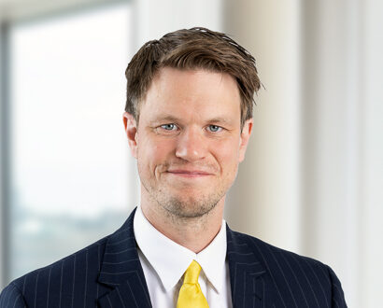

Andreas Hallbeck is a Senior Associate in Roschier’s Corporate Compliance & Investigations practice in Stockholm. He is a member of the Swedish Bar Association and is also qualified to practice law in New York as a member of the New York State Bar.
Andreas advises on corporate compliance, crisis management, and dispute avoidance. He is experienced in leading internal investigations into alleged breaches of company code of conduct and violations of law, and in working with multi-jurisdictional white-collar crime investigations. He gained valuable in-house experience by working as a visiting lawyer at publicly listed Nordic companies with global operations.
Andreas is also experienced in the field of dispute resolution. He has acted as counsel for clients in international and domestic arbitration proceedings under the ICC Rules, the SCC Rules, and the UNCITRAL Arbitration Rules, as well as in litigation proceedings in Swedish courts.
Andreas holds a Swedish LL.M. degree, as well as a US LL.M. degree which he completed as a Fulbright scholar at the University of Texas. He also studied international law and common law at the University of Auckland in New Zealand.

Career
Roschier (2018-)
SSAB, Visting lawyer (2024)
Nokia Corporation, Visiting Lawyer (2021)
University of Texas School of Law, Research Fellow (2017–2018)
White & Case, Associate, (2016-2018)
Ashurst, Associate, (2014-2016)

Memberships
Member of the Swedish Bar Association
Member of the New York State Bar
Member of the Young Arbitrators Sweden (YAS)

Publications
“Denuntiationsprincipen i ett föränderligt sakrättsligt landskap – särskilt om rådighetsavskärandebedömningen”(“The requirement of transaction notification in a property law context undergoing change – specifically regarding the requirement that the debtor is cut off from the transaction property”), Juridisk Publikation, 02/2015

Recent speaking engagements
“Unconscionability – A legal ‘hail mary pass’ or an effective legal basis in commercial disputes?”, Young Arbitrators Sweden, Panel discussion (moderator), Stockholm, Sweden, September 2024
“Investment Arbitration In the Nordics“, Nordic Arbitration Day (panelist), Oslo, Norway, January 2023
“Assessing, presenting and proving damages for breach of share purchase agreements“, Roschier Arbitration Forum (panelist), Stockholm, Sweden, May 2022

Education
University of Texas School of Law, LL.M. (2018)
Stockholm University, LL.M. (2014)

Languages
English, Swedish

